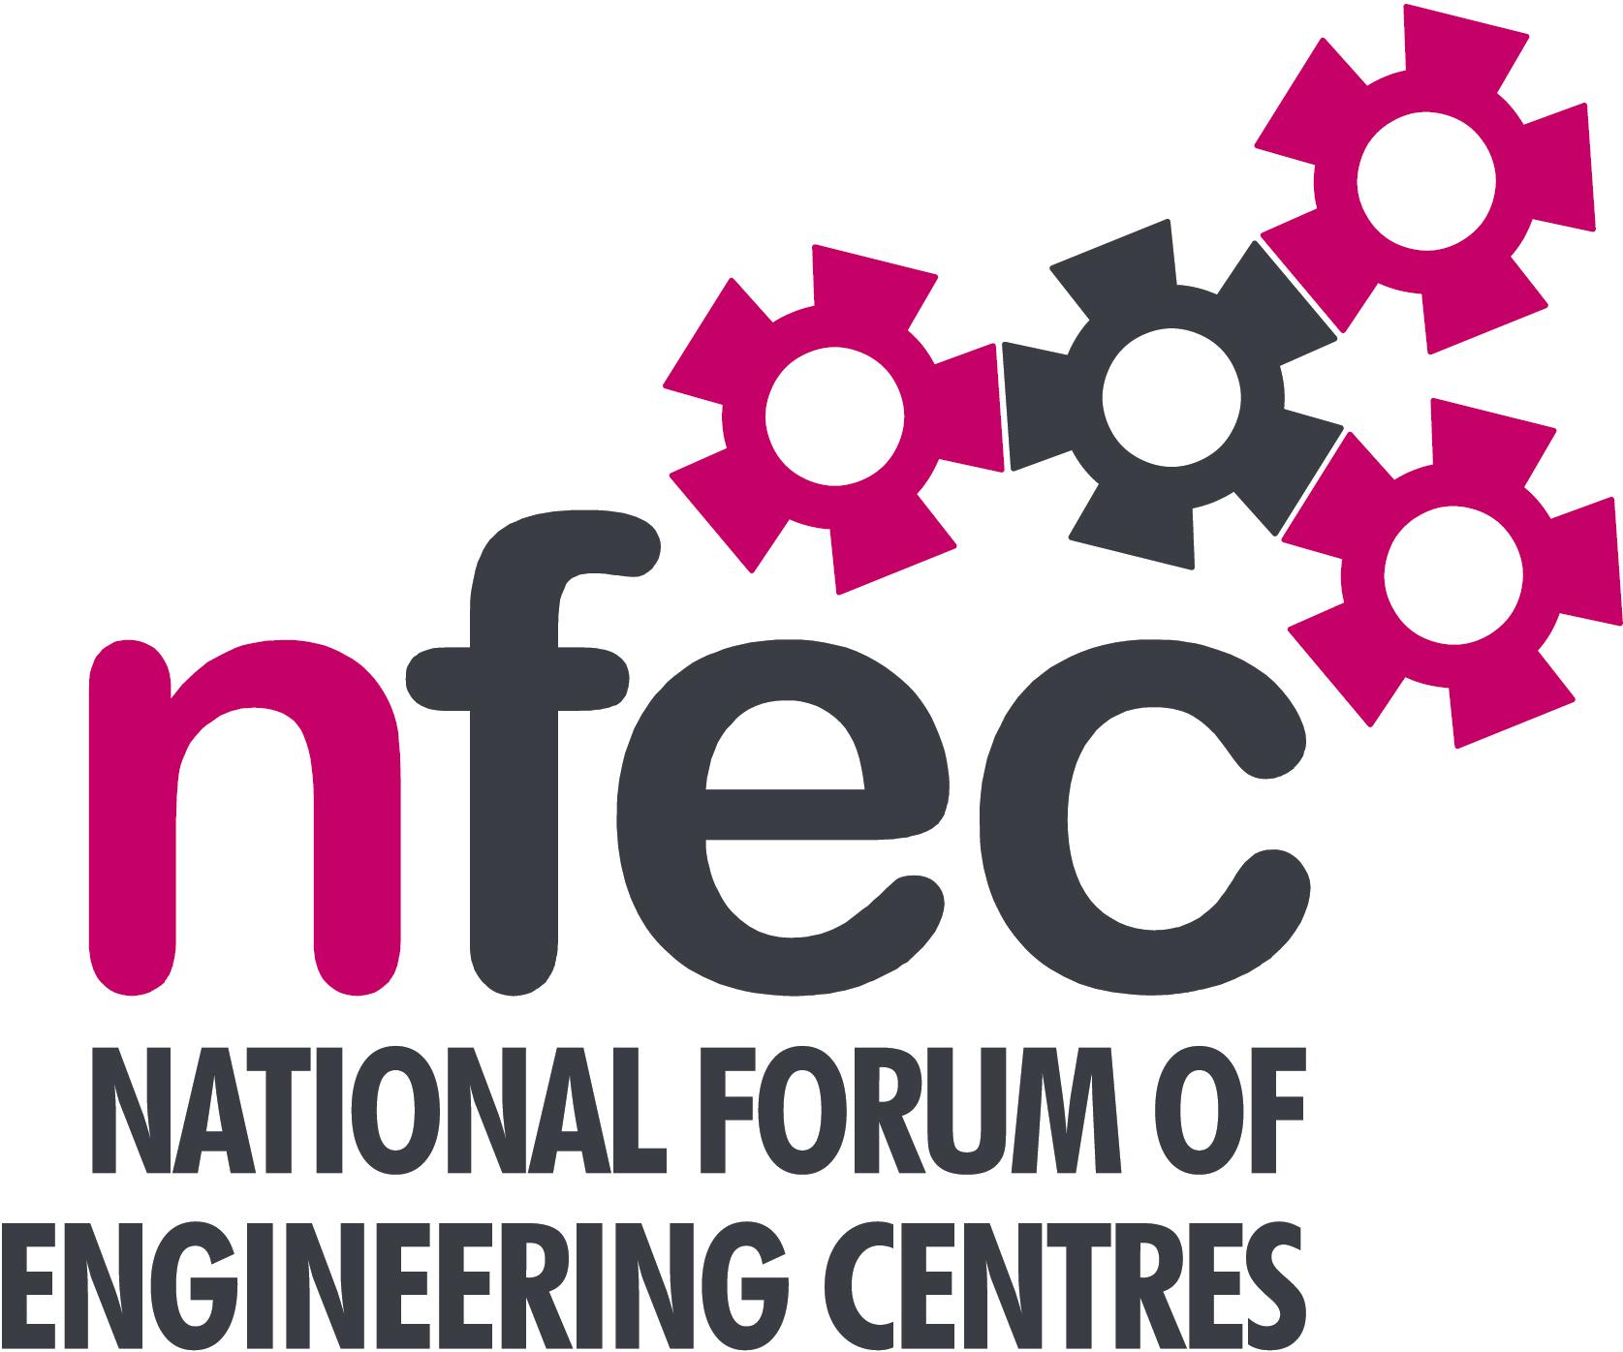
London and the South East
– NFEC Summer 2015 Regional Seminar
Host: IPS International, Rochester

Friday 26th June 2015, 10.15am – 2.45pm (Coffee from 10.00am)
Venue: Northbank House, Sir Thomas Longley Road, Medway City Estate, Rochester ME2 4DU
Telephone Number: 01634 298800

PROGRAMME

- Welcome and Introduction to the Seminar | Kim Hollands - London and SE Regional Coordinator | 10.15
- Current matters of concern relating to quality, content, structure, management and delivery of programmes of training and education in Engineering (not included on Agenda) - an opportunity for open discussion with a focus to distill key issues and plans for addressing them.  - Aprenticeship Trailblazer Initiative - Update on Trailblazer Developments and related issues including feedback from two of these groups that NFEC has representation on – Automobile Manufacture and Aerospace.  Tea/Coffee | All delegates and Kim Hollands  Bob Millington - NFEC Director for Regional Coordination and National Liaison  Andrew Hewison –C&G but on behalf of Awarding Organisations qualification changes | 10.20  10.30  11.30
- Women into Engineering – presentation on TechWomenUK including research data, resources for use in marketing and running promotional sessions and how to get involved in the project itself  Lunch & Demonstrations by Exhibitors  - Tour of facilities at IPS International  - Qualifications, Awarding Bodies – Current developments and general issues.  - Plenary session – Issues to note and agreed actions for NFEC  - Date, Place and Topics for next Seminar | Christina Conroy OBE, Director of Coralesce and Project Director of TechWomenUK  Kim Hollands  Adrian Lewis - EAL  Christine Hepworth-James – Pearson  Andrew Hewison - C&G  Phillip Bryant - AQA  All Delegates / Kim Hollands  All delegates / Kim Hollands | 11.45  12.45  13.30  14.00  14.30  14.45
Close  Entry is free to this seminar. A light buffet lunch will be provided and  you will be able to see/discuss demonstrations of the latest available equipment and facilities for the delivery of learning in Engineering | To book your place: Email: admin@nfec.org.uk  Phone: 07759 901229

